Phase 1:
- Create Project:
Only User with the Administrator role should be able to create project. Create users for the project with Frist name, Lastname, Email. Users created in the project should support SSO login. Users created will be assigned one of the 3 roles. Test Manager, Test Lead or Test Analyst.
User who is logged in as Test Manager should see only that projects, he was part of. Test Manager should be able to assign the test cycles, test suites for the project. If the test cycles or test suites not visible, he should be able to create those and then assign to the project. Other Users Test Lead or Test Analyst should not have access to create/assign test cycles or test suites to the project
- Create Requirements:
Any user who belongs to the project should be able to create the requirement. There should be 2 ways to create the requirement
- Select Project, Test Suite, Test cycle. Upload the requirement document in pdf/docx/doc/csv to generate the Requirements out of that. Each Requirement generated should contain ReqID, Header, Description, Test suite, Test Cycle, Date Created, Status. Status should be “Draft” by default. Only the user who has “Test Manager” role should be able to update the status from “Draft” to “Approved”.
- Select Project, Test Suite, Test cycle. Create Requirement Manually. When Creating the Requirement manually – Header and Description are the 2 fields user need to enter. Each Requirement generated should contain ReqID, Header, Description, Test suite, Test Cycle, Date Created, Status. Status should be “Draft” by default. Only the user who has “Test Manager” role should be able to update the status from “Draft” to “Approved”.
- Any users who belong to the project should be able to “Delete” the Requirement created, if the requirement is not attached to any test cases.

- Create Test Cases from Requirements:
Any user who belongs to the project should be able to create the Test Cases. There should be 2 ways to create the Test Cases.
- Select ReqID-Header combination is one text dropdown. Click Generate test cases to generate the test case from AI. Each Test Case should have ReqID, TestCaseID, Test Suite, Test Cycle, Assignee (Assignee should be only users from the project), Test Case Header, Test Case Description, Status (Statuses are Draft, Inprogress, Defect, Resolved, Not applicable, Retest), Date Created, Due Date.
- Select ReqID-Header combination is one text dropdown. Add Test cases manually. When adding the test case manually, user should input only “Test Case Header” and “Test Case Description”. Each Test Case generated should have ReqID, TestCaseID, Test Suite, Test Cycle, Assignee (Assignee should be only users from the project), Test Case Header, Test Case Description, Status (Statuses are Draft, Inprogress, Defect, Resolved, Not applicable, Retest), Date Created, Due Date. User should have option to upload the test cases from csv file as well with just “Test Case Header” and “Test Case Description”.
- Any users who belong to the project should be able to “Delete” the Test cases created and whose status is “Draft”.

- Create Ad hoc Test Cases

Any user who belongs to the project should be able to create the test cases manually or upload the test cases using csv file. This scenario is for directly creating or uploading test cases without requirements.
- Select Project, Test Suite, Test cycle. Upload the test cases using csv file. User should input only “Test Case Header” and “Test Case Description” in csv file. Each Test Case generated should have TestCaseID, Test Suite, Test Cycle, Assignee (Assignee should be only users from the project), Test Case Header, Test Case Description, Status (Statuses are Draft, Inprogress, Defect, Resolved, Not applicable, Retest), Date Created, Due Date. ReqID will be blank where test cases are not generated from ReqID.
- Select Project, Test Suite, Test cycle. Add the test cases manually. User should input only “Test Case Header” and “Test Case Description” . Each Test Case generated should have TestCaseID, Test Suite, Test Cycle, Assignee (Assignee should be only users from the project), Test Case Header, Test Case Description, Status (Statuses are Draft, Inprogress, Defect, Resolved, Not applicable, Retest), Date Created, Due Date. ReqID will be blank where test cases are not generated from ReqID.
- Any users who belong to the project should be able to “Delete” the Test cases created and whose status is “Draft”.

- View and Export Test cases:

Any user who belongs to the project should be able to view or export the test cases
- View- User should select the Project to view test cases. Further filters like test suite and test cycle should pop up in drop down based on project selected. User should be able to further filter based on fields in the test cases to view the test cases.
- Export – User should be able to export the test cases in csv or pdf format from the view screen
Phase 2:
“Test Manager” user who belongs to the project should be able get predefined test cases
- User should select the Project, Test Cycle and Test suite to get the predefined Test cases. Each Test Case generated should have TestCaseID, Test Suite, Test Cycle, Assignee (Assignee should be only users from the project), Test Case Header, Test Case Description, Status (Statuses are Draft, Inprogress, Defect, Resolved, Not applicable, Retest), Date Created, Due Date. ReqID will be blank where test cases are not generated from ReqID.
- “Test Manager” should have access to delete to Test cases generated out of predefined ones
Phase 3:
Execute the test cases only for Timekeeping, Payroll export, Accrual, Persona.
Need to explore technical feasibility more on this. Phase 3 will be decoupled from phase 1 and 2
Phase 4:
Execute the test cases only for Person Import, Business Structure, Labor Categories. Need to explore technical feasibility more on this. Phase 4 will be decoupled from phase 1, 2 and 3.

Phase 5:
Execute the test cases for other UKG modules, Integrations. Need to explore technical feasibility more on this. Phase 4 will be decoupled from phase 1, 2, 3 and 4.

Expected Outcome
- Centralized QA management.
- Reusable test suites across projects.
- End-to-end traceability from requirements to test cases.
- Faster and more consistent testing.

Technical Architecture

1. Proposed Technology Stack
Layer | Technology
Frontend | React, TypeScript, Material UI
Backend | Java 21, Spring Boot
API | OpenAPI / REST APIs
Authentication | Microsoft Entra ID
Security | Spring Security
Messaging | RabbitMQ / Azure Service Bus
Database | PostgreSQL
Storage | Azure Blob Storage
Automation | Playwright
Integration | UKG REST APIs, Boomi APIs, SFTP, Database Connectors
Reporting | Power BI, PDF, Excel
Monitoring | Application Insights, OpenTelemetry
Secrets | Azure Key Vault
Deployment | Docker Containers

2. High Level Architecture
The solution uses a layered, service-oriented architecture that separates user experience, application services, execution workers, assurance controls, evidence storage and reporting. This design supports secure multi-project operation, controlled parallel execution and end-to-end traceability across UKG and connected systems.
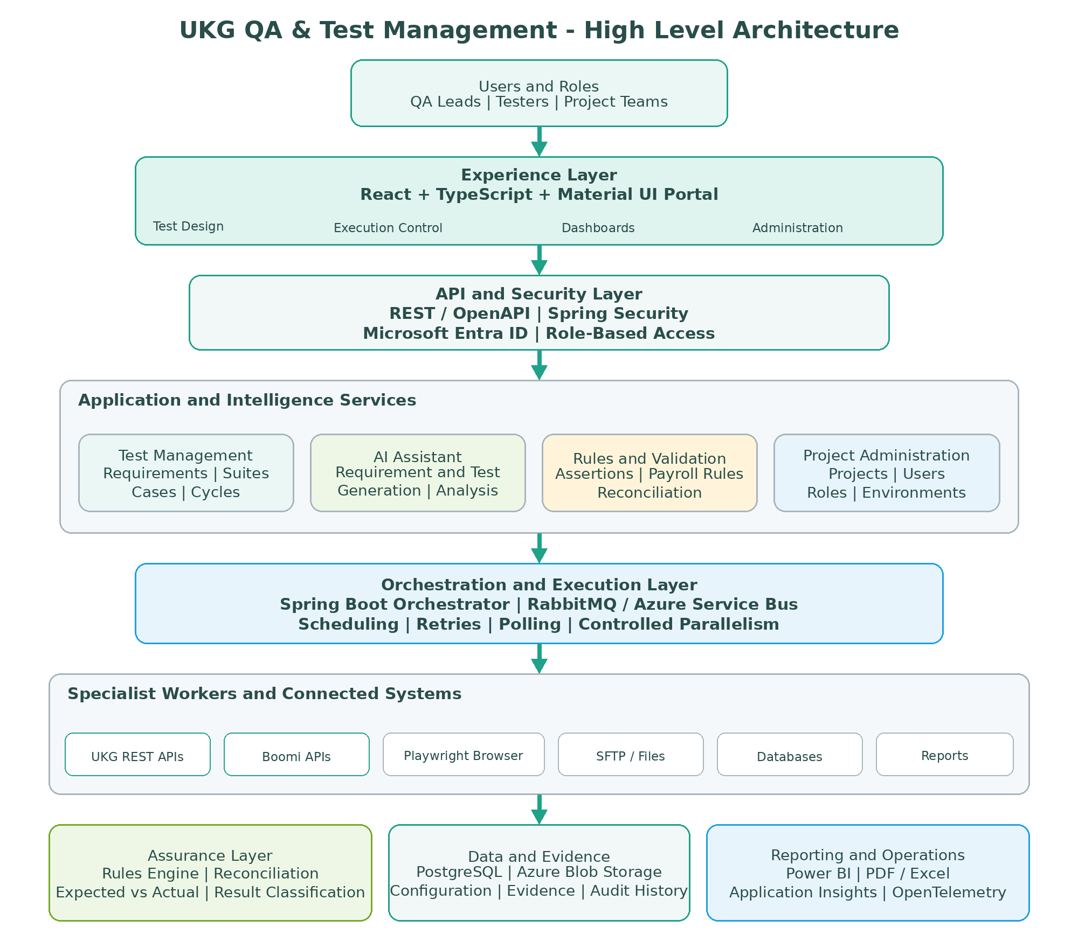
Figure 1: High-level architecture for the UKG QA and Test Management platform

3. Backend Microservices
Microservice | Responsibilities
Authentication Service | Entra ID authentication, JWT, RBAC, tenant isolation
Project Management Service | Projects, environments, users, roles
Requirement Service | Requirement management and AI extraction
Test Management Service | Suites, cycles, test cases, Excel import
Execution Service | Scheduling, retries, polling, orchestration
Connector Service | UKG APIs, Boomi, SFTP, DB, Browser automation
Validation Service | Assertions, payroll rules, reconciliation
Evidence Service | Logs, screenshots, API responses, audit trail
Reporting Service | Dashboards, PDF/Excel reporting
AI Assistant Service | Requirement generation, test generation, failure analysis

Screenshots for Phase 1 and 2:



